Screenshots of output

1. Default home page with fields and validation when I submitted without entering fields.

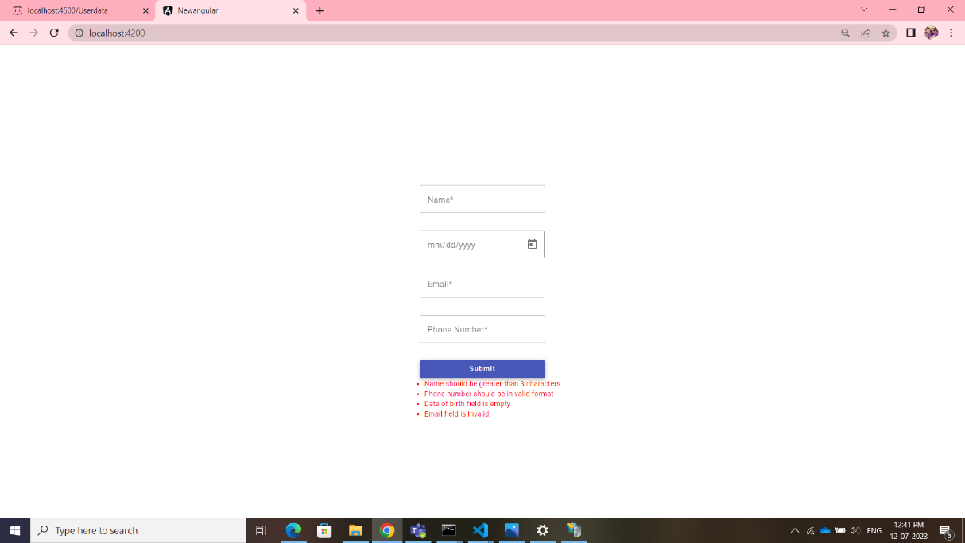

1. Trying to check the validation.

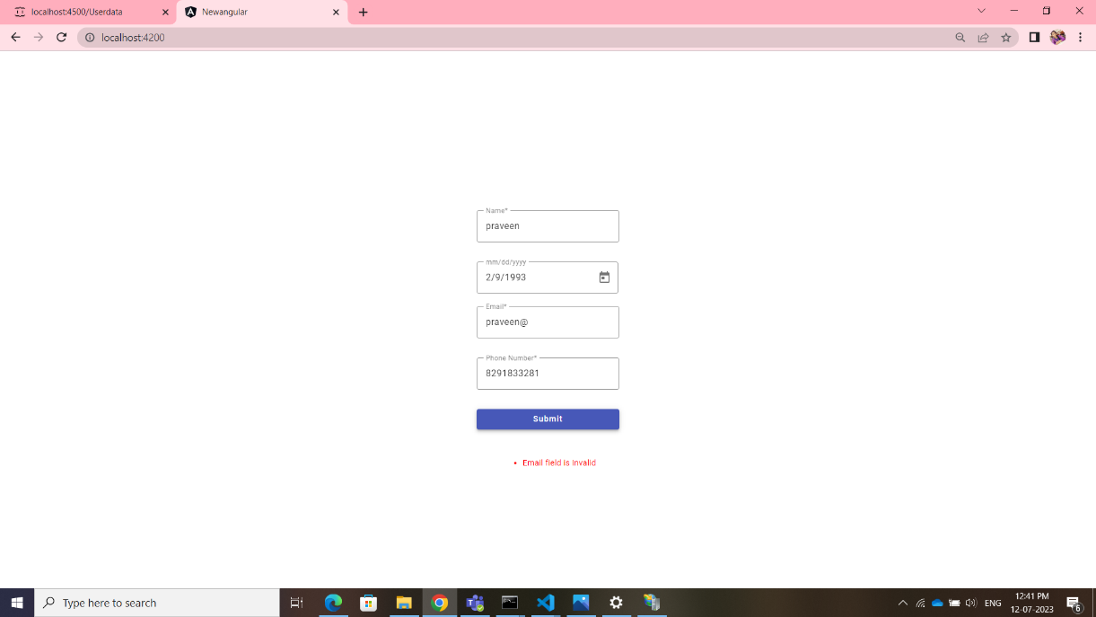

1. Data has been added to server successfully.

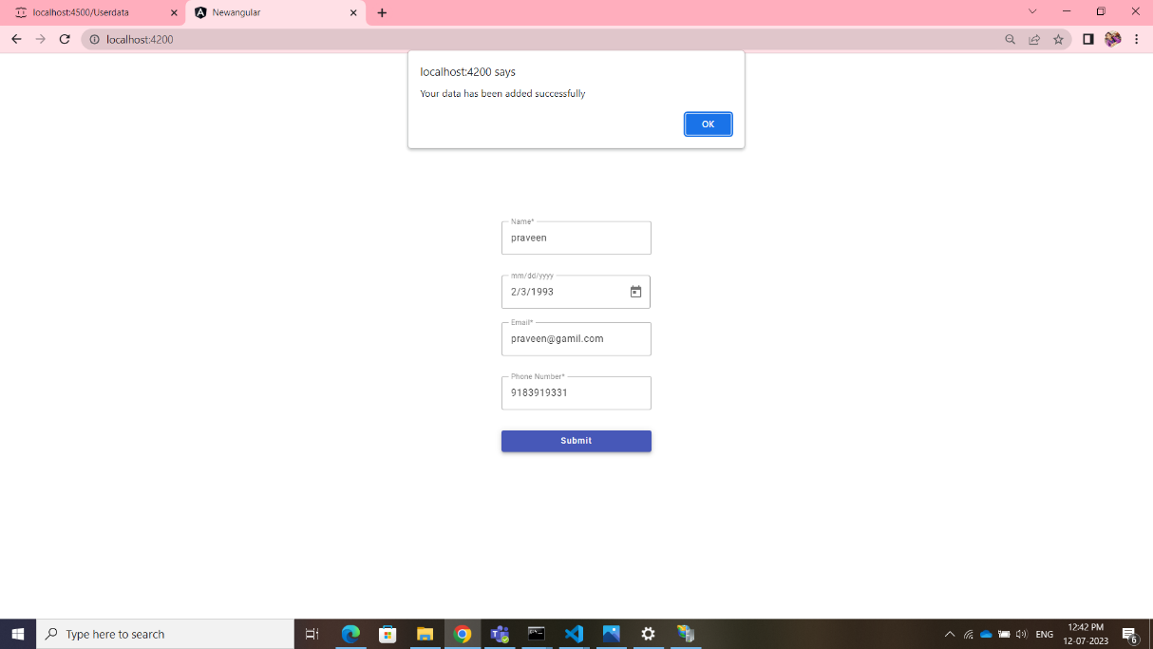

1. The JSON server used to store the data, you may see the recently saved data below.

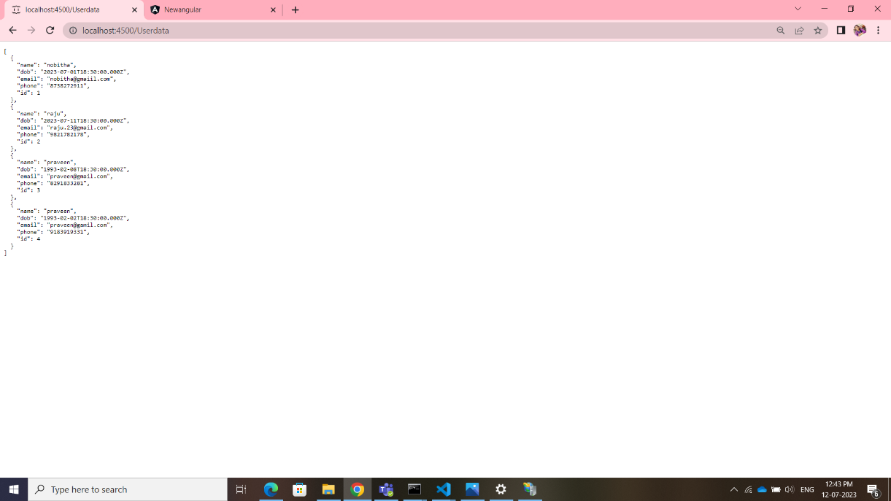

**Note**: You can find the JSON file in the project as ‘data.json’